Hydrocarbon NOMENCLATURE
“How to” guide
Hydrocarbons are the simplest of organic molecules in that they are made up of only carbon and hydrogen. There are three types of hydrocarbons – Alkanes, Alkenes, and Alkynes. Alkanes have only single carbon to carbon bonds. Alkenes have at least one carbon to carbon double bonds, and alkynes have at least one carbon to carbon triple bond.
Alkanes are of the greatest significance in the naming of organic compounds because alkanes form the main structural unit of the vast majority of organic substances. The addition of multiple bonds or any other type of atom to an alkane causes the creation of a functional group. This is why alkenes, and alkynes, and all other classes of organic molecules are consider functional groups.
Alkanes are not particularly chemically reactive and any functional groups become the centre of reactivity within a molecule. That is, it is generally the functional group which determines the reactivity of the entire molecule and much of its physical properties.
Since alkanes are the most fundamental types of organic compounds, their basic carbon chain (or skeleton) provide the basis for the nomenclature of all organic compounds. The earliest nomenclature systems followed almost no systematic rules. Substances were named based on their smell, or their natural source, etc. Many of those names are still in use today and are collectively known as common names. As organic chemistry developed and structures became more complex, a systematic method for naming organic compounds became necessary. The International Union of Pure and Applied Chemistry (IUPAC) is the organism that sets the rules for nomenclature of organic compounds today. Names that follow IUPAC rules are known as systematic names, or IUPAC names.
THE SIMPLE STUFF – the three type of hydrocarbons and simple naming
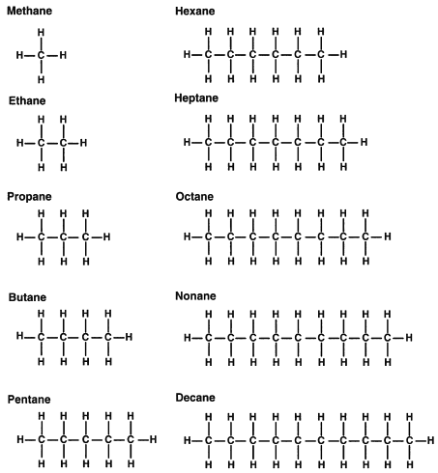
Alkanes are considered saturated, i.e. contain only single bonds (they have the highest number of H atoms, are saturated with H atoms). Alkanes form a homologous series of formula C_{n}H_{2n+2} where n is an integer. Each alkanes is named according to the number of C atoms present. The first ten alkanes are named below. Note that each name is made from a prefix (meth, eth, etc) which indicates the number of carbons in it. The suffix (ane) is used to show it is an alkane with only single c to c bonds. Complete the condensed structural, molecular formulas, and line diagrams for each one – butane is done as an example.
CH₃CH₂CH₂CH₃ C₄H₁₀

Alkenes also contain only carbon and hydrogen (a hydrocarbon), but have a double bond (or more) between some of the carbon bonds. They are considered unsaturated. Each alkenes is also named according to the number of C atoms present, but with the suffix ene rather than ane. Alkenes form a homologous series of formula C_{n}H_{2n}. Some alkenes are shown below. Complete the line diagrams for each alkene.
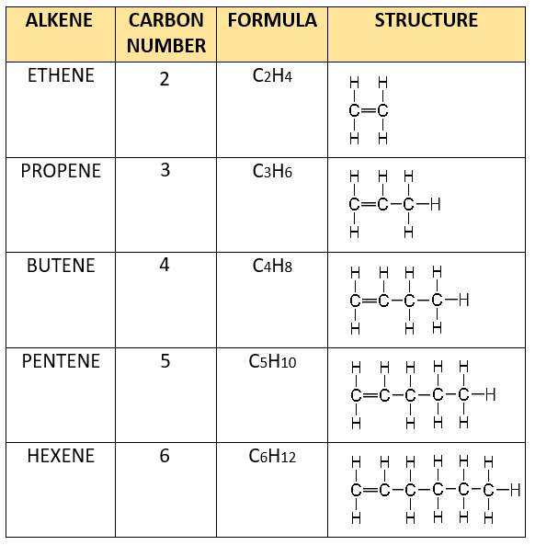
LINE DIAGRAM

Alkynes also contain only carbon and hydrogen (a hydrocarbon), but have a triple bond (or more) between some of the carbon bonds. They are also considered unsaturated. A compound with more than one double or triple bond is called polyunsaturated. Each alkyney is y named according to the number of C atoms present, but with the suffix yne rather than ane or ene. Alkynes form a homologous series of formula C_{n}H_{2n-2}. Some alkynes are shown below. Complete the line diagrams for each alknne.
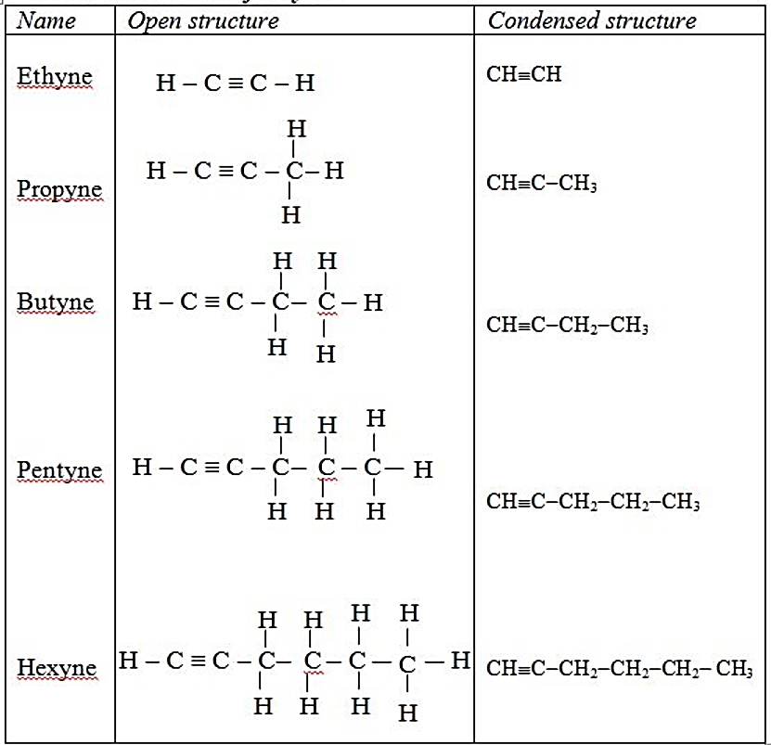
Line diagram

THE MORE COMPLICATED STUFF
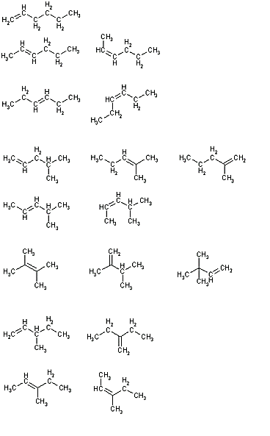
Not all simple names allow us to correctly identify the correct structure for a molecule. For example, the name hexene tells us 6 C’s and one double bond. There are quite a few different structures which could meet this criteria – some of which are shown below.
Different structural formulas for C₆H₁₂
All of the molecules above are “versions” of hexene, C₆H₁₂. These structures are called structural isomers – molecules with the same molecular formula, but different structural formula. So calling a molecule hexene does not communicate much information about the actual arrangement of atoms in the molecule. This level of ambiguity about the structure of a molecule is avoided by naming organic molecules in a systematic way – this is the purpose of the IUPAC system.
In the IUPAC system, each unique structure should have a unique name. Each of the molecules above would therefore have a unique name – not the general name of hexene. Let’s look at the rules for naming, starting with alkanes, then alkenes and alkynes.
Alkanes – nomenclature rules
Naming alkanes which are simply a single long chain of carbon atoms is easy – use the known names in the list of page 1 (methane, ethane, etc). However most alkanes are not like this. Most alkanes have a long chain of carbon atoms with one or more side chains joining onto the (long) main chain. This creates alkanes which may contain the same number of C and H atoms, but with very different structures, and slightly different chemical and physical properties. Such molecules are structural isomers of each other.
The structural isomers for alkanes are caused by substituent groups being attached to a main chain. For example, consider the three structural formulas below for C₇H₁₆.
heptane
3-methylhexane
3-ethylpentane

2,3-dimethylpentane

The first has one main carbon chain, the other examples have alkyl groups. An alkyl group is a hydrocarbon branch on a main chain. The second example has one substituent group – a one carbon alkyl group (methyl). The third example also has one substituent group – a two carbon alkyl group (ethyl). Each of these has a unique name which is created by following the rules below.
- Identify the longest carbon chain. This chain is called the parent chain.
- Identify all of the substituents (groups appending from the parent chain).
- Number the carbons of the parent chain from the end that gives the substituents the lowest numbers. When comparing a series of numbers, the series that is the "lowest" is the one which contains the lowest number at the occasion of the first difference. If two or more side chains are in equivalent positions, assign the lowest number to the one which will come first (alphabetical) in the name.
- If the same substituent occurs more than once, a number for where each one occurs is given. In addition, the number of times the substituent group occurs is indicated by a prefix (di, tri, tetra, etc.).
- If there are two or more different substituents they are listed in alphabetical order using the base name (ignore the prefixes di, tri, tetra, etc.).
- If chains of equal length are competing for selection as the parent chain, then the choice goes in series to the chain which has the greatest number of side chains.
Watch Professor Dave’s two YouTube videos on naming alkanes - Part 1 and Part 2. He mentions the correct use of comma and hyphen. You need to be particular about these.
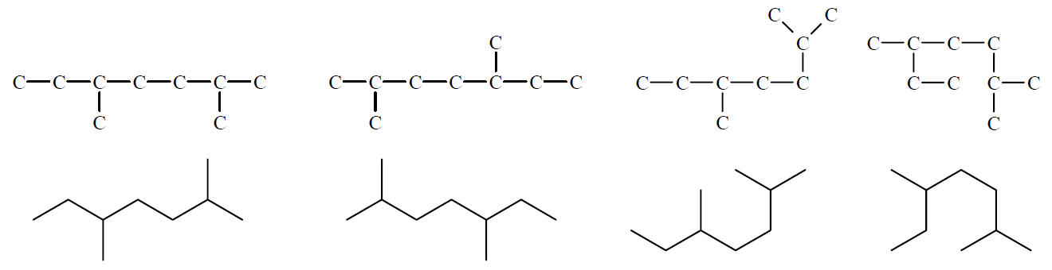
Note: Don’t be fooled by the drawing or formula in front of you. The same structure can be drawn many different ways. Below are the ways 2,5 – dimethylheptane can be represented.
Alkenes – nomenclature rules
Naming Alkenes is similar to alkanes, but the double bond has a higher priority than any of the alkyl branches. This has two significant impacts on naming the structure.
- Identify the longest main chain which contains the carbon double bond.
- Number this chain from the end that will give the lowest number to the double bond.
- Name this longest chain according to the number of C’s in it, using the suffix ene. Identify the number of the C atom at which the double bond starts, and use this number with the main chain name. Chains with more than one double bond are named using diene, triene, etc.
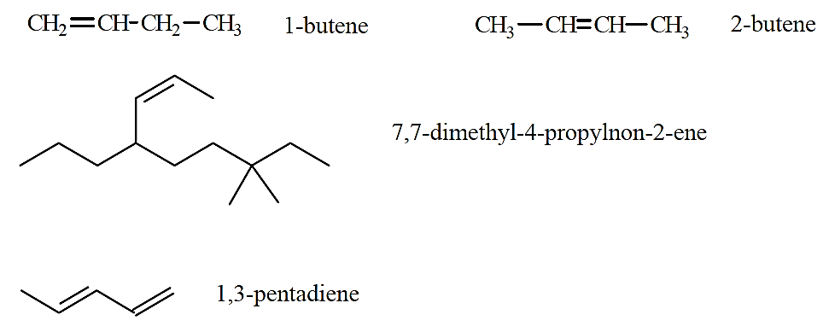
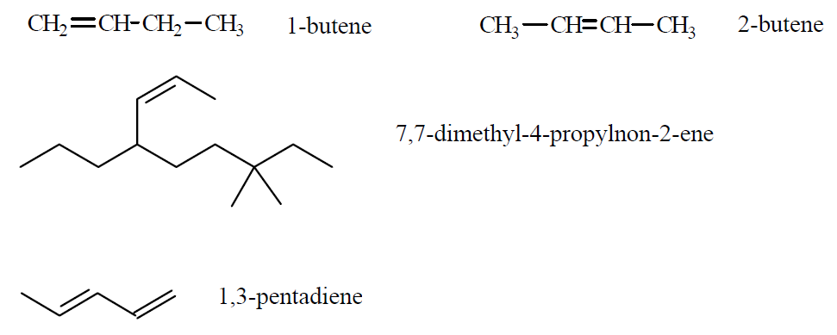
- Follow the alkane rules 2, 4, 5.

Alkynes – nomenclature rules
Naming Alkynes is similar to alkenes, but a triple bond has a lower priority than a double bond, but higher than any alkyl or halogen substituent groups. That means if both double and triple bonds are present the double bond is given the lowest number (double bond is higher priority). However a triple bond is given the lowest number if only alkyl or halogen substituent groups are present. The suffix yne is used for alkynes.
Do the worksheet “Nomenclature – hydrocarbons and haloalkanes” – a page in the OneNote homework section.
Do questions from your text book p.12, Q’s 1-4.
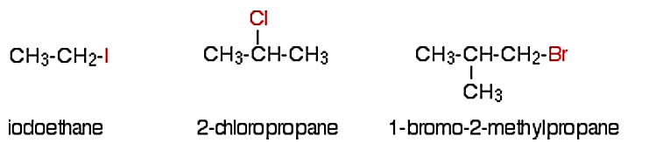
Note: Q’s 3b, 4a, and 4b ask you to name a hydrocarbon with a halogen substituent group. There is a reason your textbook does this – halogens have the same priority in naming that hydrocarbons do. Halogen substituents like bromine and chlorine can therefore be named using the same rules as hydrocarbons, but with slightly different names – bromo, chloro, fluro, iodo.

